1. News feed relating to recommendation systems

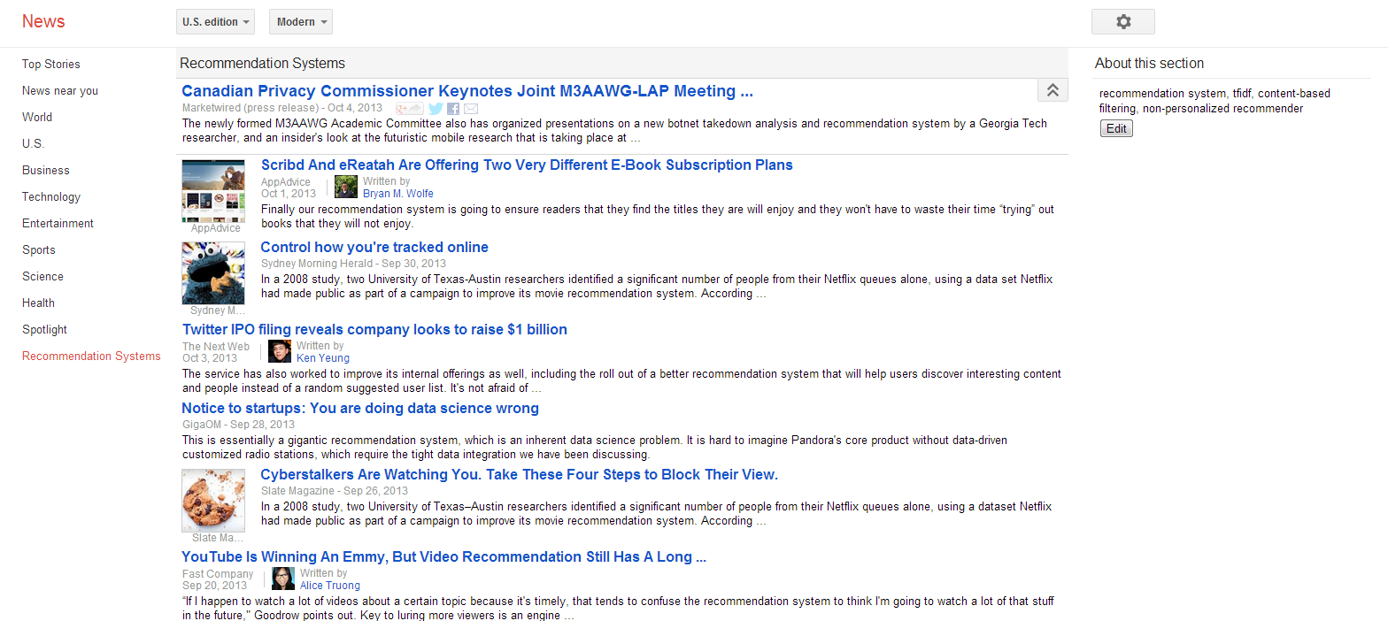

As the snapshot above, I just create a news feed called “recommendation systems” on the left list. When I click on that feed (the tag is marked in red), it shows me lots of news about recommendation systems.

Here is my analysis:

Goal: To show me news relating to recommendation systems

Profile terms: recommendation system, tfidf, content-based filtering, non-personalized recommender

Performance: It works well in general which provides me lots of news about business use cases of recommendation systems

Improvement: there is one news “Meet Microsoft's Surface 2 And Surface Pro 2” which only contains keyword “recommendation system” but is nothing to it actually. I hope it should not only be relating to keyword but content.

1. News feed relating to movies

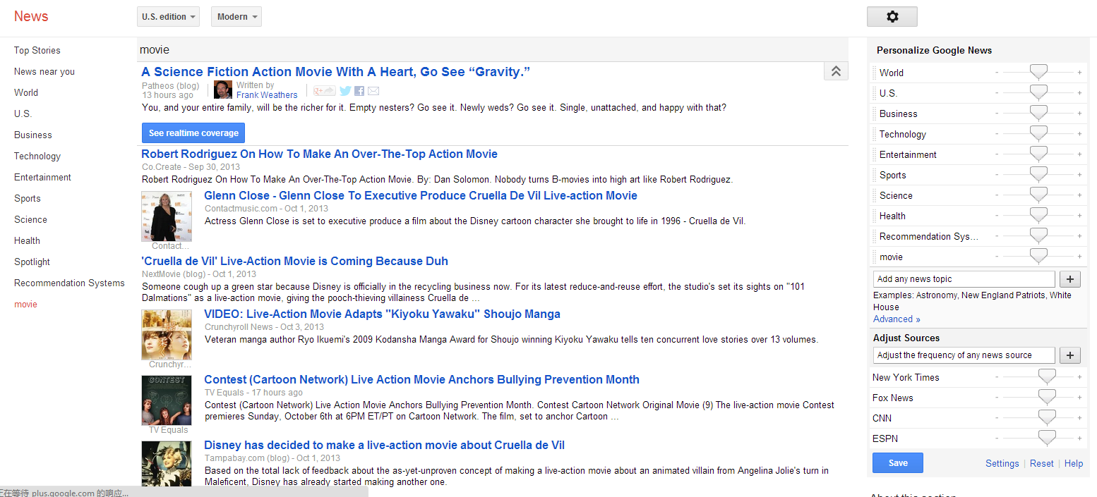

I create another “movie” new feed in the same way. You can find a red tag “movie” on the left list and if you click on it, it shows you the news about movies as above.

Here is my analysis:

Goal: To show me news relating to interesting movies

Profile terms: action movie, science fiction

Performance: It works well in general which provides me the introductions to some science fiction action movies

Improvement: I hope it can categorize those news since there are movie for music video and photography method for movie while I am really interested in new movie introduction

1. News feed relating to travel

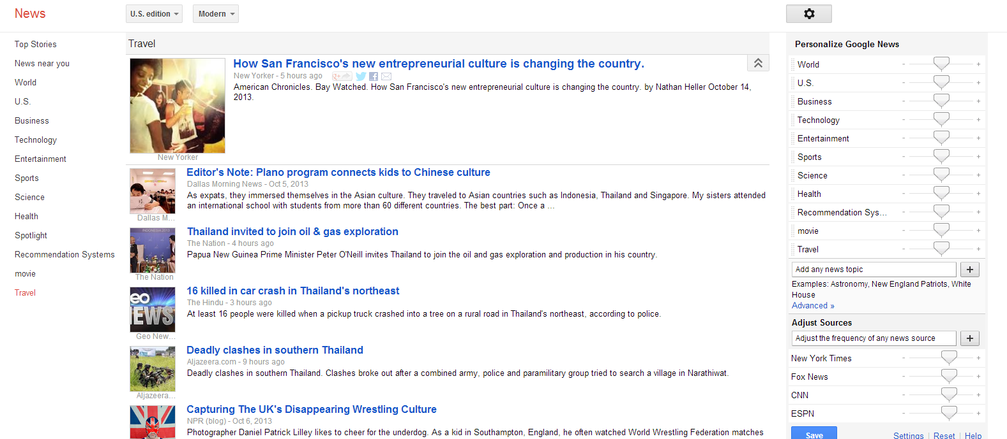

Finally I create a news feed called “Travel”. The above screenshot shows several news from this feed.

Here is my analysis:

Goal: To show me news relating to travelling to Phuket Island, Thailand

Profile terms: Thailand, Phuket Island, culture, scenery spot

Performance: It doesn’t provide me useful info about traveling to Thai.

Improvement: I hope it can link keyword “scenery spot” to travel but it seems not. This is what I hope to improve.